Cabinet Vision Setup.
The cabinet vision link consists of the exporting of a project from Cabinet Vision to an Microsoft Access database. The user will then import the line items from that access database into an estimate.
The import allows for the importing of Cabinets, Tops and Moldings

Import Screen Setup.
The import screen is the first screen you encounter after specifying the access database that you would like to import. To ensure the data is displayed correctly, you will need to add in 2 records to the Modulesetup Table as shown below
Note: a SQL script is included in this document at the end that will add all required records to your database for you.
You need to add 2 records to ensure that the import screen shows the correct information. This data goes in the MODULESETUP table.
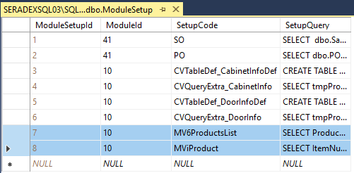

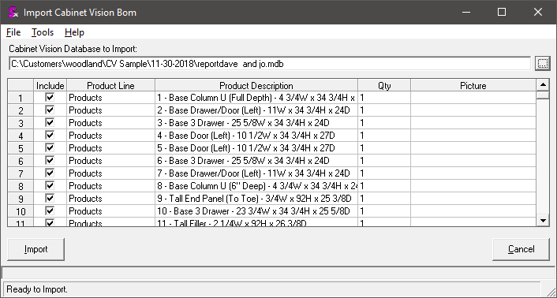

MV6ProductsList
SELECT Products.JobsIndex, ProductsIndex, IIf(Products.CabinetID > 0, Products.CabinetID, IIf(Products.TopID > 0,Products.TopID,Products.MouldingID)) & ' - ' & Products.Description & ' - ' &
IIf(Products.Width <> '', Products.Width & 'W x ', '') & IIf(Products.Height <> '', Products.Height & 'H x ', '') & IIf(Products.Depth <> '', Products.Depth & 'D', '') AS Description, Qty, Picture
FROM Products

MViProduct
SELECT ItemNumber, ISNULL(Comments, '') + ' | ' + ISNULL(Comments2, '') + ' | ' + ISNULL(Comments3, '') AS Comment, Handle, Picture,
CASE WHEN Main.CabinetID > 0 THEN CONVERT(VARCHAR, Main.CabinetID) ELSE CASE WHEN Main.TopID > 0 THEN CONVERT(VARCHAR, Main.TopID)
ELSE CONVERT(VARCHAR, Main.MouldingID) END END + ' - ' + Main.ProductDescription + ' - ' +
CASE WHEN Main.Width <> '' THEN Main.Width + 'W x ' ELSE '' END + CASE WHEN Main.Height <> '' THEN Main.Height + 'H x ' ELSE '' END +
CASE WHEN Main.Depth <> '' THEN Main.Depth + 'D' ELSE '' END AS Description
FROM #ImportProductTable# AS Main

To address certain issues such as thickness being recorded in the description, a stored procedure is also required.
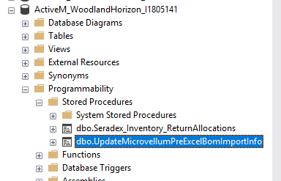

USE [ActiveM_WoodlandHorizon_I1805141]
GO
/****** Object: StoredProcedure [dbo].[UpdateMicrovellumPreExcelBomImportInfo] Script Date: 03/12/2019 9:59:47 AM ******/
SET ANSI_NULLS ON
GO
SET QUOTED_IDENTIFIER ON
GO
-- =============================================
-- Author: <Seradex>
-- Create date: <February 28, 2019>
-- Description: <This custom procedure allows to customize the MV/CV imported data prior to loading into Excel sheet>
-- =============================================
Create PROCEDURE [dbo].[UpdateMicrovellumPreExcelBomImportInfo]
-- Add the parameters for the stored procedure here
@TableNamesTempTable VARCHAR(255)
AS
BEGIN
-- SET NOCOUNT ON added to prevent extra result sets from
-- interfering with SELECT statements.
SET NOCOUNT ON;

DECLARE @sql NVARCHAR(max);
DECLARE @ImportInfoTypeValue VARCHAR(255);
DECLARE @ParamDefinition NVARCHAR(max);
DECLARE @tempVirtualSpecStrucTableName VARCHAR(255);
DECLARE @tempPartsTableName VARCHAR(255);
DECLARE @tempSubPartsTableName VARCHAR(255);
DECLARE @Level INT;
DECLARE @LastLevel INT;
DECLARE @KeyFieldPrefix VARCHAR(100);

IF @TableNamesTempTable is not null BEGIN
begin tran
SET @sql = 'SELECT @ActualTableNameOut = ActualTableName FROM ' + @TableNamesTempTable + ' WHERE ImportInfoType = @ImportInfoType';
SET @ParamDefinition = '@ImportInfoType VARCHAR(255), @ActualTableNameOut VARCHAR(255) OUTPUT';
SET @ImportInfoTypeValue = 'Struc';

EXECUTE sp_executesql @sql, @ParamDefinition, @ImportInfoType = @ImportInfoTypeValue, @ActualTableNameOut = @tempVirtualSpecStrucTableName OUTPUT;
SELECT @tempVirtualSpecStrucTableName;

IF @tempVirtualSpecStrucTableName is not null BEGIN
SET @KeyFieldPrefix = Replace(@tempVirtualSpecStrucTableName, '#', '');

SET @sql = 'SELECT @ActualTableNameOut = ActualTableName FROM ' + @TableNamesTempTable + ' WHERE ImportInfoType = @ImportInfoType';
SET @ImportInfoTypeValue = 'Parts';

EXECUTE sp_executesql @sql, @ParamDefinition, @ImportInfoType = @ImportInfoTypeValue, @ActualTableNameOut = @tempPartsTableName OUTPUT;
SELECT @tempPartsTableName;

IF @tempPartsTableName is not null BEGIN
--Update the QtyPer, TotalQty, etc. to factor the thickness value for Parts components
SET @sql = 'UPDATE tmpVirtualSpecStruc
SET QtyPer = ISNULL(tmpVirtualSpecStruc.QtyPer, 0) * qryMaterialThickness.MaterialThickness,
TotalQty = ISNULL(tmpVirtualSpecStruc.TotalQty, 0) * qryMaterialThickness.MaterialThickness,
QtyRequired = ISNULL(tmpVirtualSpecStruc.QtyRequired, 0) * qryMaterialThickness.MaterialThickness,
QtyToCost = ISNULL(tmpVirtualSpecStruc.QtyToCost, 0) * qryMaterialThickness.MaterialThickness
FROM ' + @tempVirtualSpecStrucTableName + ' AS tmpVirtualSpecStruc
INNER JOIN (SELECT DISTINCT tmpParts.ChildItemID, tmpParts.MaterialThickness
FROM ' + @tempPartsTableName + ' AS tmpParts INNER JOIN Items ON tmpParts.ChildItemID = Items.ItemID
INNER JOIN UOMs ON Items.UOMID = UOMs.UOMID
WHERE (ISNULL(tmpParts.MaterialThickness, 0) <> 0) AND (UOMs.UOMCode = ''BDFT'')) AS qryMaterialThickness
ON tmpVirtualSpecStruc.ChildItemID = qryMaterialThickness.ChildItemID'

EXEC(@sql)
END

SET @sql = 'SELECT @ActualTableNameOut = ActualTableName FROM ' + @TableNamesTempTable + ' WHERE ImportInfoType = @ImportInfoType';
SET @ImportInfoTypeValue = 'SubParts';

EXECUTE sp_executesql @sql, @ParamDefinition, @ImportInfoType = @ImportInfoTypeValue, @ActualTableNameOut = @tempSubPartsTableName OUTPUT;
SELECT @tempSubPartsTableName;

IF @tempSubPartsTableName is not null BEGIN
--Update the QtyPer, TotalQty, etc. to factor the thickness value for SubParts components.
SET @sql = 'UPDATE tmpVirtualSpecStruc
SET QtyPer = ISNULL(tmpVirtualSpecStruc.QtyPer, 0) * qryMaterialThickness.MaterialThickness,
TotalQty = ISNULL(tmpVirtualSpecStruc.TotalQty, 0) * qryMaterialThickness.MaterialThickness,
QtyRequired = ISNULL(tmpVirtualSpecStruc.QtyRequired, 0) * qryMaterialThickness.MaterialThickness,
QtyToCost = ISNULL(tmpVirtualSpecStruc.QtyToCost, 0) * qryMaterialThickness.MaterialThickness
FROM ' + @tempVirtualSpecStrucTableName + ' AS tmpVirtualSpecStruc
INNER JOIN (SELECT DISTINCT tmpSubParts.ChildItemID, tmpSubParts.MaterialThickness
FROM ' + @tempSubPartsTableName + ' AS tmpSubParts INNER JOIN Items ON tmpSubParts.ChildItemID = Items.ItemID
INNER JOIN UOMs ON Items.UOMID = UOMs.UOMID
WHERE (ISNULL(tmpSubParts.MaterialThickness, 0) <> 0) AND (UOMs.UOMCode = ''BDFT'')) AS qryMaterialThickness
ON tmpVirtualSpecStruc.ChildItemID = qryMaterialThickness.ChildItemID'

EXEC(@sql)
END

--Update the TotalRootQty
SET @sql = 'SELECT @LastLevelOut = MAX([Level]) FROM ' + @tempVirtualSpecStrucTableName + ' AS tmpVirtualSpecStruc';
SET @ParamDefinition = '@LastLevelOut INT OUTPUT';

EXECUTE sp_executesql @sql, @ParamDefinition, @LastLevelOut = @LastLevel OUTPUT;

IF @LastLevel is not null BEGIN
SET @Level = 2
WHILE (@Level <= @LastLevel) BEGIN
SET @sql = 'UPDATE tmpVirtualSpecStruc
SET tmpVirtualSpecStruc.TotalRootQty = qryChildrenTotalRootQty.TotalRootQty
FROM ' + @tempVirtualSpecStrucTableName + ' AS tmpVirtualSpecStruc
INNER JOIN (SELECT ISNULL(VirtualSpecStrucParents.TotalRootQty, 0) * ISNULL(VirtualSpecStrucChildren.TotalRootQty, 0) AS TotalRootQty, VirtualSpecStrucChildren.' + @KeyFieldPrefix + 'ID
FROM ' + @tempVirtualSpecStrucTableName + ' AS VirtualSpecStrucChildren INNER JOIN ' + @tempVirtualSpecStrucTableName + ' AS VirtualSpecStrucParents
ON VirtualSpecStrucChildren.ParentOccurance = VirtualSpecStrucParents.' + @KeyFieldPrefix + 'ID
AND VirtualSpecStrucChildren.ItemID = VirtualSpecStrucParents.ChildItemID
WHERE (VirtualSpecStrucChildren.[Level] = ' + Convert(VarChar(50), @Level) + ')) AS qryChildrenTotalRootQty
ON tmpVirtualSpecStruc.' + @KeyFieldPrefix + 'ID = qryChildrenTotalRootQty.' + @KeyFieldPrefix + 'ID'

EXEC(@sql)
SET @Level = @Level + 1
END
END
END
commit tran
END
END

Setting up Custom Data Export.
You are able to setup custom data from the Access database to be sent to the excel file.
Note, this is a 2-step process in that you need to specify the creation of a temp table using SQL syntax and then build a query in access to select the data that you want and insert it into that temp table. Once that is complete, another query is specified to extract the data from the temp tables and place them on the worksheets you specified.
CAUTION!!
There is a hardcoded where clause that you have to keep in mind. Since the access database stores the data for all the cabinets, but the import goes cabinet by cabinet, the query you write will have a where clause appended to it. The where clause that you cant control is using fields from [dbo].[##tmpMV_Products]. Ensure that you have joined that table to all your queries (the ones that send data to excel) to ensure there are no issues.
Within the Import Menu choice, under the TOOLS menu, you will need to use the Additional Data Setup option.
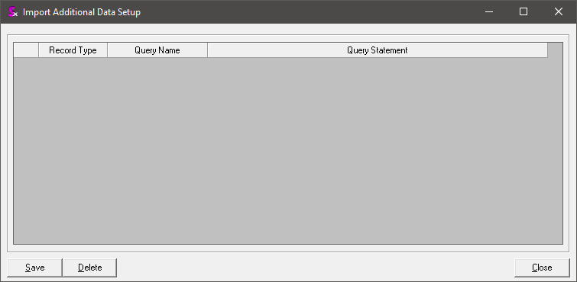

There are 2 record types that you can choose.:

Table Definition
The table definition should be the first query that you execute. The purpose of this option is to allow for the creation of a temp table in SQL. As such, you must follow standard SQL language and define the table and the structure of the fields in the table that you would like to create.
This query will have 2 parts in that you create the table (SQL syntax) and then specify the query (Access syntax) to populate that table.
Note that the temp table name is wrapped in ##. The code will convert it so that it uses the ##TempTable syntax to ensure that each sessionID in SQL gets its own unique table.

Also, these queries need to be simplistic. Do not create queries that join numerous tables together as they will fail. The goal is to just copy the records you need into temp tables from SQL. Then you can create a query that joins those temp tables together and places the data into excel.
To keep things running as quick as possible, limit the columns of data that you are going to pull down.
Example:
CREATE TABLE #Cabinets# (ID int identity PRIMARY KEY, [RoomID] int, [CabinetID] int, [CabinetName] varchar(50), [Description] varchar(255), [Assembly] nvarchar(max));
INSERT INTO #Cabinets# ( [RoomID], [CabinetID], [CabinetName], [Description], [Assembly] )
SELECT Cabinets.[Room ID], Cabinets.[Cabinet ID], Cabinets.[Cabinet Name], Cabinets.[Description], Cabinets.[Assembly]
FROM Cabinets

Note: in the above SQL statement, there are 3 parts.
- Create table (SQL Syntax)
- Insert Into Table (SQL Syntax).
- Select (Access Syntax)
Remember that Access uses a slightly different language then SQL.

Select Query
The Select Query is used to then extract the data from your temp table and send it to the excel file. This query must be in SQL syntax as you are querying the temp table you created previously.
Example:
SELECT tmpProducts.ProductDescription, tmpCabinets.[CabinetName], tmpCabinets.[Description], tmpCabinets.[Assembly]
FROM #ImportProductTable# AS tmpProducts LEFT JOIN #Cabinets# AS tmpCabinets ON tmpProducts.CabinetID = tmpCabinets.CabinetID

Notice in the above query, we are bringing in the ImportProductsTable (temp table). This table has the following structure.
The join from this table to your custom table you created is where ImportProductTable.CabinetID = Cabinets.CabinetID (in the above example, the tables are aliased as tmpProducts and tmpCabinets).
Also make note of the #WhereClause# (not shown but is run in code). This is a hardcoded where clause being injected into your select statement. The key is the PRODUCTSINDEX. This value is the row number you selected during the import process (the checkbox). This will be used to ensure you don’t pull all the records into the excel file for all “cabinets”. Rather, it is used to ensure we only pull for the “cabinet” that is currently being worked on.

Excel Sheet
The excel sheet that the data is sent to depends on the SELECT QUERY setup. The sheet name must exist and must be the exact same name as you specified on the screen for the “Query Name”.
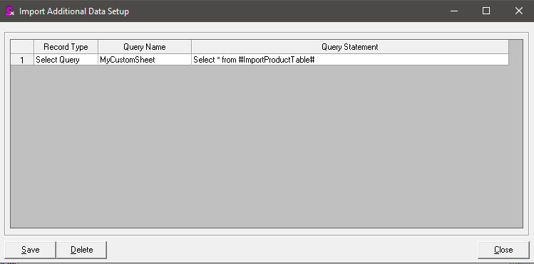

Misc Notes:
- The query statement window, you can double click it to maximize and paste in your query.
- Watch the SQL statements. The program does not appear to like trailing “;” (without the quotes).
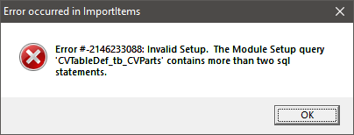

Check your query in the Modulesetup table. Odds are you have a “;” at the very end of the statements.
- Ensure you only pull the data that you need. Each query will slow the process down as it has to create the temp table, fill the temp table, read the temp table and populate to excel.
- The data that is written to the excel file, it starts on cell A3.
- There are no column headings written via the tool to the excel sheet. To make things easier for you and the customer you should set these on the sheet as needed.

Errors:
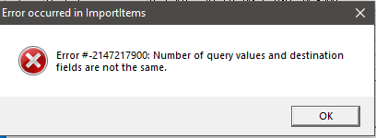
Either the table you created does not have enough columns specified in relation to your insert statement or your select statement has more then your insert query. So check your query to ensure you have all the fields mapped up properly.

Sample Setup:
The list below is the current sample data setup that is being used as of 03/18/2019. This data is subject to change so please check to ensure things have not changed.
- CVTableDef_tb_Tops
CREATE TABLE #Tops#
(RoomID int,
WallID int,
TopID int,
LinealTotal float,
SquareTotal float,
EdgeTotal float,
Miter float,
Width float,
WidthString varchar(250),
Length float ,
LengthString varchar(250),
Thinkness float,
ThicknessString varchar(250),
MaterialID int,
Description varchar(250)
);
INSERT INTO #Tops#
(RoomID,
WallID,
TopID,
LinealTotal,
SquareTotal,
EdgeTotal,
Miter,
Width,
WidthString,
Length,
LengthString,
Thinkness,
ThicknessString,
MaterialID,
Description
)
SELECT [Room ID],
[Wall ID],
[Top ID],
[Lineal Total],
[Square Total],
[Edge Total],
Miter,
Width,
[Width String],
Length,
[Length String],
Thick,
[Thick String],
[Material ID],
Description
FROM Tops
- CVTableDef_tb_Rooms
CREATE TABLE #Rooms#
(RoomID INT,
RoomName VARCHAR(250),
ExtAsmFin VARCHAR(250),
IntAsmFin VARCHAR(250),
TopFin VARCHAR(250),
SplashFin VARCHAR(250),
CrownFin VARCHAR(250),
LightRailFin VARCHAR(250),
BaseBoardFin VARCHAR(250),
ChairRailFin VARCHAR(250),
CeilingFin VARCHAR(250),
EDoorFin VARCHAR(250),
WindowFin VARCHAR(250)
);
INSERT INTO #Rooms#
(RoomID,
RoomName,
ExtAsmFin,
IntAsmFin,
TopFin,
SplashFin,
CrownFin,
LightRailFin,
BaseBoardFin,
ChairRailFin,
CeilingFin,
EDoorFin,
WindowFin
)
SELECT RoomID,
RoomName,
ExtAsmFin,
[IntAsmFin],
[TopFin],
SplashFin,
CrownFin,
LightRailFin,
BaseBoardFin,
ChairRailFin,
CeilingFin,
EDoorFin,
WindowFin
FROM Rooms
- CVTableDef_tb_Moldings
CREATE TABLE #Moldings#
(RoomID INT,
MoldingID INT,
LinealTotal FLOAT,
Style VARCHAR(250),
MaterialID INT,
Thickness FLOAT,
Height FLOAT
);
INSERT INTO #Moldings#
(RoomID,
MoldingID,
LinealTotal,
Style,
MaterialID,
Thickness,
Height
)
SELECT [Room ID],
[Molding ID],
[Lineal Total],
Style,
[Material ID],
Thickness,
Height
FROM Molding
- CVTableDef_tb_Drawers
CREATE TABLE #Drawers#
([DrawerID] INT,
[CabinetID] INT,
[DraweNum] INT,
[Drawe Name] VARCHAR(250),
Width FLOAT,
[WidthString] VARCHAR(250),
Height FLOAT,
[HeightString] VARCHAR(250),
Depth FLOAT,
[DepthString] VARCHAR(250),
Cost FLOAT,
MaterialScheduleID INT,
MaterialSchedule VARCHAR(250),
GuideMaterialID INT,
GuideMaterial VARCHAR(250)
);
INSERT INTO #Drawers#
([DrawerID],
[CabinetID],
[DraweNum],
[Drawe Name],
Width,
[WidthString],
Height,
[HeightString],
Depth,
[DepthString],
Cost,
MaterialScheduleID,
MaterialSchedule,
GuideMaterialID,
GuideMaterial
)
SELECT Drawers.[Drawer ID],
Drawers.[Cabinet ID],
Drawers.[Drawer Num],
Drawers.[Drawer Name],
Drawers.Width,
TRIM(Drawers.[Width String]) AS [Width String],
Drawers.Height,
TRIM(Drawers.[Height String]) AS [Height String],
Drawers.Depth,
TRIM(Drawers.[Depth String]) AS [Depth String],
Drawers.Cost,
Drawers.MaterialScheduleID,
Drawers.MaterialSchedule,
Drawers.GuideMaterialID,
Drawers.GuideMaterial
FROM Drawers
- CVTableDef_tb_Cabinets
CREATE TABLE #Cabinets#
([RoomID] INT,
[WallID] INT,
[CabinetID] INT,
[Width] VARCHAR(250),
[Width String] VARCHAR(250),
[Height] VARCHAR(250),
[Height String] VARCHAR(250),
[Depth] VARCHAR(250),
[Depth String] VARCHAR(250),
[CabinetName] VARCHAR(250),
[CabinetType] INT,
[CabinetStyle] INT,
[Quantity] FLOAT,
[Hinge] VARCHAR(250),
[Description] VARCHAR(250)
);
INSERT INTO #Cabinets#
([RoomID],
[WallID],
[CabinetID],
[Width],
[Width String],
[Height],
[Height String],
[Depth],
[Depth String],
[CabinetName],
[CabinetType],
[CabinetStyle],
[Quantity],
[Hinge],
[Description]
)
SELECT [Room ID],
[Wall ID],
[Cabinet ID],
[Width],
[Width String],
[Height],
[Height String],
[Depth],
[Depth String],
[Cabinet Name],
[Cabinet Type],
[Cabinet Style],
[Quantity],
[Hinge],
[Description]
FROM Cabinets
- CVTableDef_tb_Doors
CREATE TABLE #Doors#
(CabinetID INT,
DoorName VARCHAR(250),
Type VARCHAR(250),
Hinge VARCHAR(250),
Width FLOAT,
WidthString VARCHAR(250),
Height FLOAT,
HeightString VARCHAR(250),
FingerPull VARCHAR(250),
EdgeProfile VARCHAR(250),
RaisedPanelDetail VARCHAR(250),
MaterialSchedule VARCHAR(250),
Label VARCHAR(250),
HingeMaterialID INT
);
INSERT INTO #Doors#
(CabinetID,
DoorName,
Type,
Hinge,
Width,
WidthString,
Height,
HeightString,
FingerPull,
EdgeProfile,
RaisedPanelDetail,
MaterialSchedule,
Label,
HingeMaterialID
)
SELECT [Cabinet ID],
[Door Name],
Type,
Hinge,
Width,
[Width String],
Height,
[Height String],
[Finger Pull],
[Edge Profile],
[Raised Panel Detail],
[Material Schedule],
Label,
[HingeMatID]
FROM Doors
- CVTableDef_tb_Materials
Create table #Materials#
(
ID int,
Name varchar(250),
Description varchar(250),
UnitofIssue int
);
Insert into #Materials#
(ID,
Name,
Description,
UnitofIssue
)
Select cxMaterial.ID, cxMaterial.name, cxMaterial.description, cxMaterial.UnitofIssueID from cxMaterial
- CVTableDef_tb_UnitofIssue
Create table #UnitofIssue#
(
ID int,
[Name] varchar(250)
);
Insert Into #UnitofIssue#
(ID,
[Name]
)
Select CxUnitOfIssue.ID, CxUnitOfIssue.[Name] from CxUnitOfIssue
- CVTableDef_tb_CVParts
CREATE TABLE #Parts#
([CabinetID] INT,
[PartID] INT,
Width FLOAT,
[WidthString] VARCHAR(250),
Length FLOAT,
[LengthString] VARCHAR(250),
[MaterialID] INT,
[DoorID] INT,
[DrawerID] INT,
[TopID] INT,
NumDado FLOAT,
NumDrill FLOAT,
[Description] VARCHAR(250)
);
INSERT INTO #Parts#
([CabinetID],
[PartID],
Width,
[WidthString],
Length,
[LengthString],
[MaterialID],
[DoorID],
[DrawerID],
[TopID],
NumDado,
NumDrill,
[Description]
)
SELECT Parts_CV.[Cabinet ID],
Parts_CV.[Part ID],
Parts_CV.Width,
TRIM([parts_CV].[Width String]) AS [WidthString],
Parts_CV.Length,
TRIM([parts_CV].[Length String]) AS [LengthString],
Parts_CV.[Material ID],
Parts_CV.[Door ID],
Parts_CV.[Drawer ID],
Parts_CV.[Top ID],
Parts_CV.NumDado,
Parts_CV.NumDrill,
TRIM([parts_CV].[Description]) AS [Description]
FROM Parts_CV;

From the above temp table creations, the following select statements are being used to extract data to excel. Note that the below text does not include the #WhereClause#. However, the script at the end does.

- CabinetData
SELECT cabinets.Roomid,
cabinets.wallid,
cabinets.cabinetid,
cabinets.width,
LTRIM(cabinets.[width string]) AS [WidthString],
cabinets.height,
LTRIM(cabinets.[Height String]) AS [HeightString],
cabinets.depth,
LTRIM(cabinets.[depth string]) AS DepthString,
cabinets.cabinetname,
case cabinets.cabinetType
when 1 then 'Base'
when 2 then 'Upper'
when 3 then 'Tall'
when 4 then 'Vanity'
when 5 then 'Appliance'
when 6 then 'Acessory'
when 7 then 'Decroative'
when 8 then 'Top'
when 9 then 'Molding'
when 10 then 'Wall'
when 11 then 'WallFace'
when 12 then 'Floor'
when 13 then 'Ceiling'
when 14 then 'Door' end as CabinetType,
case cabinets.cabinetstyle
when 1 then 'Standard'
when 2 then 'BlindRight'
when 3 then 'BlindLeft'
when 4 then 'Corner45'
when 5 then 'Corner90'
when 6 then 'Filler'
when 7 then 'Desk'
when 8 then 'Hood'
when 9 then 'Refer'
when 10 then 'Valance'
when 11 then 'UCValance'
when 12 then 'ApplGarage'
when 13 then 'DishWasher'
when 14 then 'TrashComp'
when 15 then 'Range'
when 16 then 'CookTop'
when 17 then 'Sink'
when 18 then 'Microwave'
when 19 then 'Window'
when 20 then 'EntryDoor'
when 21 then 'Picture' end as cabinetstyle,
cabinets.quantity,
cabinets.hinge,
cabinets.description
FROM [dbo].[##Cabinets] cabinets
inner join [dbo].[##tmpMV_Products] as tmpProducts on cabinets.cabinetid = tmpProducts.cabinetID

- DoorData
SELECT doors.cabinetid,
doors.doorname,
doors.type,
doors.hinge,
doors.width,
LTRIM(doors.widthstring) AS WidthString,
doors.height,
LTRIM(doors.heightstring) AS HeightString,
doors.fingerpull,
doors.edgeprofile,
doors.raisedpaneldetail,
doors.materialschedule,
doors.label,
materials.name as HingeMatName,
materials.description as HingeMatDescription
FROM [dbo].[##Doors] doors
left outer join [dbo].[##Materials] materials on doors.HingeMaterialID = materials.ID
inner join [dbo].[##tmpMV_Products] tmpProducts on doors.cabinetID = tmpProducts.cabinetID
- DrawerData
SELECT Drawers.DrawerID,
Drawers.CabinetID,
Drawers.DraweNum,
Drawers.[Drawe Name],
Drawers.width,
LTRIM(Drawers.widthstring) AS WidthString,
Drawers.height,
LTRIM(Drawers.[HeightString]) AS HeightString,
Drawers.depth,
LTRIM(Drawers.DepthString) AS DepthString,
Drawers.cost,
Drawers.MaterialSchedule,
Drawers.GuideMaterial
FROM [dbo].[##Drawers] Drawers
INNER JOIN [dbo].[##tmpMV_Products] tmpProducts ON Drawers.cabinetID = tmpProducts.CabinetID
- Moldingdata
SELECT Moldings.MoldingID,
Moldings.LinealTotal,
Moldings.Style,
Moldings.Thickness,
Moldings.Height,
materials.name as MoldingMaterialName,
materials.description as MoldingMaterialDescription
FROM [dbo].[##Moldings] Moldings
left outer join [dbo].[##Materials] Materials on moldings.MaterialID = Materials.id
inner join
[dbo].[##tmpMV_Products] tmpProducts on Moldings.MoldingID = tmpProducts.mouldingID
- TopData
SELECT tops.TopID,
tops.description,
tops.LinealTotal,
tops.Width,
LTRIM(tops.WidthString) AS WidthString,
tops.length,
LTRIM(tops.lengthstring) AS LengthString,
tops.thinkness,
LTRIM(tops.thicknessstring) AS ThicknessString,
m.name AS TopMaterialName,
m.description AS TopMaterialDescription
FROM [dbo].[##Tops] AS Tops
LEFT OUTER JOIN [dbo].[##Materials] M ON tops.materialid = m.id
LEFT OUTER JOIN
(
SELECT p.topid,
width,
LTRIM(widthstring) AS WidthString,
length,
LTRIM(Lengthstring) AS LengthString
FROM [dbo].[##parts] p
WHERE p.topid > 0
) AS P ON tops.topid = p.topid
inner join [dbo].[##tmpMV_Products] tmpProducts on tops.topid = tmpProducts.topid
- CabinetDataParts
SELECT cabinet.CabinetID,
Cabinet.Width,
Cabinet.Height,
Cabinet.Depth,
parts.description,
parts.width,
parts.widthstring,
parts.length,
parts.lengthString,
parts.numdado,
parts.numdrill,
parts.PartMaterialDescription,
parts.PartMaterialName
FROM [dbo].[##Cabinets] cabinet
LEFT OUTER JOIN
(
SELECT p.cabinetID,
width,
LTRIM(WidthString) AS WidthString,
length,
LTRIM(LengthString) AS LengthString,
numdado,
numdrill,
p.description,
m.name AS PartMaterialName,
m.description AS PartMaterialDescription
FROM [dbo].[##Parts] P
LEFT OUTER JOIN [dbo].[##Materials] M ON p.MaterialID = m.ID
WHERE doorid = 0
AND drawerid = 0
AND topid = 0
) parts ON parts.cabinetID = cabinet.cabinetID
INNER JOIN [dbo].[##tmpMV_Products] tmpProducts ON cabinet.cabinetid = tmpProducts.CabinetID

Notes:
The best way to watch what is going on is to use the following.
- Use SQL profiler as it will show you the statements that are being used. However, since some are being done in code using MS Jet, you will not be able to see access based activities.
- Use the option to view the sheet as the import is happening. This way you can see the data in the excel file as well as the temp tables.
- The #WhereClause# is case sensitive. Meaning, capitalize the W and the C and the rest lowercase or it will cause errors.
- The temp tables that are created will remain in place while importing (viewing the excel file). To help you build the queries that use these temp tables, do the following:
  - Open SQL Management Studio
  - Go to the Temp table section
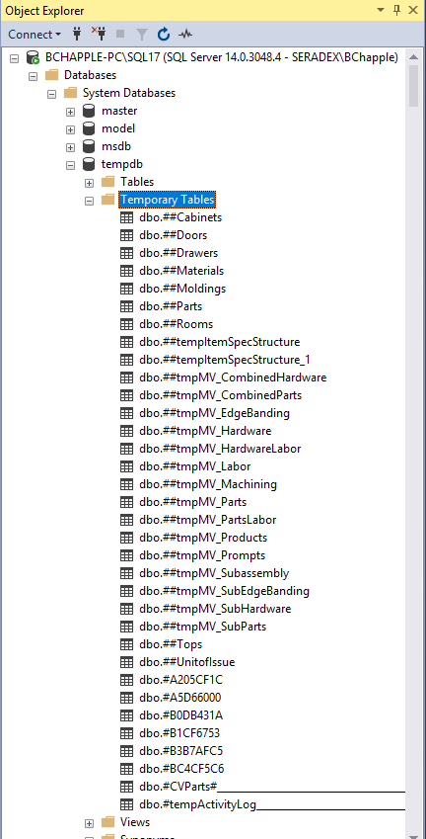
In the above, you can see the custom tables in red. However, you can also use the other core tables as you need for the select query to excel portion.

  - Left click to select a temp table
  - Use CTRL + C (keyboard for copy command).
  - Open a new sql query
  - Type “Select * from “ and then paste from the clip board. It will paste in the temp table for you.
  - You can now see what is inside that table
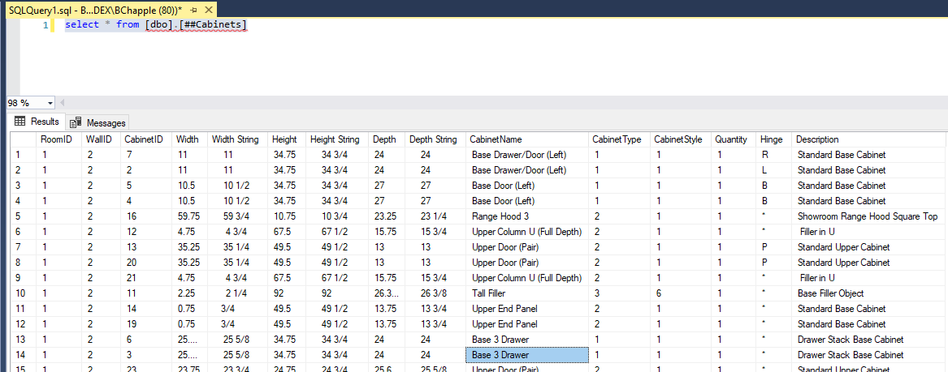
Note that all cabinets are here, not just the one(s) you selected for import. Remember that the Select query for excel will have a hardcoded WHERE clause (#WhereClause#) added.

ModuleSetup Queries
Below is a script that can be run against your ActiveM database to set it up for the imports.
The queries below rely on the following worksheet names identified in green

USE [ActiveM_XXXXXX]
GO
INSERT [dbo].[ModuleSetup] ([ModuleId], [SetupCode], [SetupQuery]) VALUES (10, N'MV6ProductsList', N'SELECT Products.JobsIndex, ProductsIndex, IIf(Products.CabinetID > 0, Products.CabinetID, IIf(Products.TopID > 0,Products.TopID,Products.MouldingID)) & '' - '' & Products.Description & '' - '' &
IIf(Products.Width <> '''', Products.Width & ''W x '', '''') & IIf(Products.Height <> '''', Products.Height & ''H x '', '''') & IIf(Products.Depth <> '''', Products.Depth & ''D'', '''') AS Description, Qty, Picture
FROM Products')
GO
INSERT [dbo].[ModuleSetup] ([ModuleId], [SetupCode], [SetupQuery]) VALUES (10, N'MViProduct', N'SELECT ItemNumber, ISNULL(Comments, '''') + '' | '' + ISNULL(Comments2, '''') + '' | '' + ISNULL(Comments3, '''') AS Comment, Handle, Picture,
CASE WHEN Main.CabinetID > 0 THEN CONVERT(VARCHAR, Main.CabinetID) ELSE CASE WHEN Main.TopID > 0 THEN CONVERT(VARCHAR, Main.TopID)
ELSE CONVERT(VARCHAR, Main.MouldingID) END END + '' - '' + Main.ProductDescription + '' - '' +
CASE WHEN Main.Width <> '''' THEN Main.Width + ''W x '' ELSE '''' END + CASE WHEN Main.Height <> '''' THEN Main.Height + ''H x '' ELSE '''' END +
CASE WHEN Main.Depth <> '''' THEN Main.Depth + ''D'' ELSE '''' END AS Description
FROM #ImportProductTable# AS Main')
GO
INSERT [dbo].[ModuleSetup] ([ModuleId], [SetupCode], [SetupQuery]) VALUES (10, N'CVTableDef_tb_Tops', N'CREATE TABLE #Tops#
(RoomID int,
WallID int,
TopID int,
LinealTotal float,
SquareTotal float,
EdgeTotal float,
Miter float,
Width float,
WidthString varchar(250),
Length float ,
LengthString varchar(250),
Thinkness float,
ThicknessString varchar(250),
MaterialID int,
Description varchar(250)
);
INSERT INTO #Tops#
(RoomID,
WallID,
TopID,
LinealTotal,
SquareTotal,
EdgeTotal,
Miter,
Width,
WidthString,
Length,
LengthString,
Thinkness,
ThicknessString,
MaterialID,
Description
)
SELECT [Room ID],
[Wall ID],
[Top ID],
[Lineal Total],
[Square Total],
[Edge Total],
Miter,
Width,
[Width String],
Length,
[Length String],
Thick,
[Thick String],
[Material ID],
Description
FROM Tops')
GO
INSERT [dbo].[ModuleSetup] ([ModuleId], [SetupCode], [SetupQuery]) VALUES (10, N'CVTableDef_tb_Rooms', N'CREATE TABLE #Rooms#
(RoomID INT,
RoomName VARCHAR(250),
ExtAsmFin VARCHAR(250),
IntAsmFin VARCHAR(250),
TopFin VARCHAR(250),
SplashFin VARCHAR(250),
CrownFin VARCHAR(250),
LightRailFin VARCHAR(250),
BaseBoardFin VARCHAR(250),
ChairRailFin VARCHAR(250),
CeilingFin VARCHAR(250),
EDoorFin VARCHAR(250),
WindowFin VARCHAR(250)
);
INSERT INTO #Rooms#
(RoomID,
RoomName,
ExtAsmFin,
IntAsmFin,
TopFin,
SplashFin,
CrownFin,
LightRailFin,
BaseBoardFin,
ChairRailFin,
CeilingFin,
EDoorFin,
WindowFin
)
SELECT RoomID,
RoomName,
ExtAsmFin,
[IntAsmFin],
[TopFin],
SplashFin,
CrownFin,
LightRailFin,
BaseBoardFin,
ChairRailFin,
CeilingFin,
EDoorFin,
WindowFin
FROM Rooms
')
GO
INSERT [dbo].[ModuleSetup] ([ModuleId], [SetupCode], [SetupQuery]) VALUES (10, N'CVTableDef_tb_Moldings', N'CREATE TABLE #Moldings#
(RoomID INT,
MoldingID INT,
LinealTotal FLOAT,
Style VARCHAR(250),
MaterialID INT,
Thickness FLOAT,
Height FLOAT
);
INSERT INTO #Moldings#
(RoomID,
MoldingID,
LinealTotal,
Style,
MaterialID,
Thickness,
Height
)
SELECT [Room ID],
[Molding ID],
[Lineal Total],
Style,
[Material ID],
Thickness,
Height
FROM Molding')
GO
INSERT [dbo].[ModuleSetup] ([ModuleId], [SetupCode], [SetupQuery]) VALUES (10, N'CVTableDef_tb_Drawers', N'CREATE TABLE #Drawers#
([DrawerID] INT,
[CabinetID] INT,
[DraweNum] INT,
[Drawe Name] VARCHAR(250),
Width FLOAT,
[WidthString] VARCHAR(250),
Height FLOAT,
[HeightString] VARCHAR(250),
Depth FLOAT,
[DepthString] VARCHAR(250),
Cost FLOAT,
MaterialScheduleID INT,
MaterialSchedule VARCHAR(250),
GuideMaterialID INT,
GuideMaterial VARCHAR(250)
);
INSERT INTO #Drawers#
([DrawerID],
[CabinetID],
[DraweNum],
[Drawe Name],
Width,
[WidthString],
Height,
[HeightString],
Depth,
[DepthString],
Cost,
MaterialScheduleID,
MaterialSchedule,
GuideMaterialID,
GuideMaterial
)
SELECT Drawers.[Drawer ID],
Drawers.[Cabinet ID],
Drawers.[Drawer Num],
Drawers.[Drawer Name],
Drawers.Width,
TRIM(Drawers.[Width String]) AS [Width String],
Drawers.Height,
TRIM(Drawers.[Height String]) AS [Height String],
Drawers.Depth,
TRIM(Drawers.[Depth String]) AS [Depth String],
Drawers.Cost,
Drawers.MaterialScheduleID,
Drawers.MaterialSchedule,
Drawers.GuideMaterialID,
Drawers.GuideMaterial
FROM Drawers')
GO
INSERT [dbo].[ModuleSetup] ([ModuleId], [SetupCode], [SetupQuery]) VALUES (10, N'CVTableDef_tb_Cabinets', N'CREATE TABLE #Cabinets#
([RoomID] INT,
[WallID] INT,
[CabinetID] INT,
[Width] VARCHAR(250),
[Width String] VARCHAR(250),
[Height] VARCHAR(250),
[Height String] VARCHAR(250),
[Depth] VARCHAR(250),
[Depth String] VARCHAR(250),
[CabinetName] VARCHAR(250),
[CabinetType] INT,
[CabinetStyle] INT,
[Quantity] FLOAT,
[Hinge] VARCHAR(250),
[Description] VARCHAR(250)
);
INSERT INTO #Cabinets#
([RoomID],
[WallID],
[CabinetID],
[Width],
[Width String],
[Height],
[Height String],
[Depth],
[Depth String],
[CabinetName],
[CabinetType],
[CabinetStyle],
[Quantity],
[Hinge],
[Description]
)
SELECT [Room ID],
[Wall ID],
[Cabinet ID],
[Width],
[Width String],
[Height],
[Height String],
[Depth],
[Depth String],
[Cabinet Name],
[Cabinet Type],
[Cabinet Style],
[Quantity],
[Hinge],
[Description]
FROM Cabinets')
GO
INSERT [dbo].[ModuleSetup] ([ModuleId], [SetupCode], [SetupQuery]) VALUES (10, N'CVTableDef_tb_Doors', N'CREATE TABLE #Doors#
(CabinetID INT,
DoorName VARCHAR(250),
Type VARCHAR(250),
Hinge VARCHAR(250),
Width FLOAT,
WidthString VARCHAR(250),
Height FLOAT,
HeightString VARCHAR(250),
FingerPull VARCHAR(250),
EdgeProfile VARCHAR(250),
RaisedPanelDetail VARCHAR(250),
MaterialSchedule VARCHAR(250),
Label VARCHAR(250),
HingeMaterialID INT
);
INSERT INTO #Doors#
(CabinetID,
DoorName,
Type,
Hinge,
Width,
WidthString,
Height,
HeightString,
FingerPull,
EdgeProfile,
RaisedPanelDetail,
MaterialSchedule,
Label,
HingeMaterialID
)
SELECT [Cabinet ID],
[Door Name],
Type,
Hinge,
Width,
[Width String],
Height,
[Height String],
[Finger Pull],
[Edge Profile],
[Raised Panel Detail],
[Material Schedule],
Label,
[HingeMatID]
FROM Doors')
GO
INSERT [dbo].[ModuleSetup] ([ModuleId], [SetupCode], [SetupQuery]) VALUES (10, N'CVTableDef_tb_Materials', N'Create table #Materials#
(
ID int,
Name varchar(250),
Description varchar(250),
UnitofIssue int
);
Insert into #Materials#
(ID,
Name,
Description,
UnitofIssue
)
Select cxMaterial.ID, cxMaterial.name, cxMaterial.description, cxMaterial.UnitofIssueID from cxMaterial')
GO
INSERT [dbo].[ModuleSetup] ([ModuleId], [SetupCode], [SetupQuery]) VALUES (10, N'CVTableDef_tb_UnitofIssue', N'Create table #UnitofIssue#
(
ID int,
[Name] varchar(250)
);
Insert Into #UnitofIssue#
(ID,
[Name]
)
Select CxUnitOfIssue.ID, CxUnitOfIssue.[Name] from CxUnitOfIssue')
GO
INSERT [dbo].[ModuleSetup] ([ModuleId], [SetupCode], [SetupQuery]) VALUES (10, N'CVTableDef_tb_CVParts', N'CREATE TABLE #Parts#
([CabinetID] INT,
[PartID] INT,
Width FLOAT,
[WidthString] VARCHAR(250),
Length FLOAT,
[LengthString] VARCHAR(250),
[MaterialID] INT,
[DoorID] INT,
[DrawerID] INT,
[TopID] INT,
NumDado FLOAT,
NumDrill FLOAT,
[Description] VARCHAR(250)
);
INSERT INTO #Parts#
([CabinetID],
[PartID],
Width,
[WidthString],
Length,
[LengthString],
[MaterialID],
[DoorID],
[DrawerID],
[TopID],
NumDado,
NumDrill,
[Description]
)
SELECT Parts_CV.[Cabinet ID],
Parts_CV.[Part ID],
Parts_CV.Width,
TRIM([parts_CV].[Width String]) AS [WidthString],
Parts_CV.Length,
TRIM([parts_CV].[Length String]) AS [LengthString],
Parts_CV.[Material ID],
Parts_CV.[Door ID],
Parts_CV.[Drawer ID],
Parts_CV.[Top ID],
Parts_CV.NumDado,
Parts_CV.NumDrill,
TRIM([parts_CV].[Description]) AS [Description]
FROM Parts_CV')
GO
INSERT [dbo].[ModuleSetup] ([ModuleId], [SetupCode], [SetupQuery]) VALUES (10, N'CVQueryExtra_CabinetData', N'SELECT cabinets.Roomid,
cabinets.wallid,
cabinets.cabinetid,
cabinets.width,
LTRIM(cabinets.[width string]) AS [WidthString],
cabinets.height,
LTRIM(cabinets.[Height String]) AS [HeightString],
cabinets.depth,
LTRIM(cabinets.[depth string]) AS DepthString,
cabinets.cabinetname,
case cabinets.cabinetType
when 1 then ''Base''
when 2 then ''Upper''
when 3 then ''Tall''
when 4 then ''Vanity''
when 5 then ''Appliance''
when 6 then ''Acessory''
when 7 then ''Decroative''
when 8 then ''Top''
when 9 then ''Molding''
when 10 then ''Wall''
when 11 then ''WallFace''
when 12 then ''Floor''
when 13 then ''Ceiling''
when 14 then ''Door'' end as CabinetType,
case cabinets.cabinetstyle
when 1 then ''Standard''
when 2 then ''BlindRight''
when 3 then ''BlindLeft''
when 4 then ''Corner45''
when 5 then ''Corner90''
when 6 then ''Filler''
when 7 then ''Desk''
when 8 then ''Hood''
when 9 then ''Refer''
when 10 then ''Valance''
when 11 then ''UCValance''
when 12 then ''ApplGarage''
when 13 then ''DishWasher''
when 14 then ''TrashComp''
when 15 then ''Range''
when 16 then ''CookTop''
when 17 then ''Sink''
when 18 then ''Microwave''
when 19 then ''Window''
when 20 then ''EntryDoor''
when 21 then ''Picture'' end as cabinetstyle,
cabinets.quantity,
cabinets.hinge,
cabinets.description
FROM [dbo].[##Cabinets] cabinets
inner join [dbo].[##tmpMV_Products] as tmpProducts on cabinets.cabinetid = tmpProducts.cabinetID
#WhereClause#')
GO
INSERT [dbo].[ModuleSetup] ([ModuleId], [SetupCode], [SetupQuery]) VALUES (10, N'CVQueryExtra_DoorData', N'SELECT doors.cabinetid,
doors.doorname,
doors.type,
doors.hinge,
doors.width,
LTRIM(doors.widthstring) AS WidthString,
doors.height,
LTRIM(doors.heightstring) AS HeightString,
doors.fingerpull,
doors.edgeprofile,
doors.raisedpaneldetail,
doors.materialschedule,
doors.label,
materials.name as HingeMatName,
materials.description as HingeMatDescription
FROM [dbo].[##Doors] doors
left outer join [dbo].[##Materials] materials on doors.HingeMaterialID = materials.ID
inner join [dbo].[##tmpMV_Products] tmpProducts on doors.cabinetID = tmpProducts.cabinetID
#WhereClause#')
GO
INSERT [dbo].[ModuleSetup] ([ModuleId], [SetupCode], [SetupQuery]) VALUES (10, N'CVQueryExtra_DrawerData', N'SELECT Drawers.DrawerID,
Drawers.CabinetID,
Drawers.DraweNum,
Drawers.[Drawe Name],
Drawers.width,
LTRIM(Drawers.widthstring) AS WidthString,
Drawers.height,
LTRIM(Drawers.[HeightString]) AS HeightString,
Drawers.depth,
LTRIM(Drawers.DepthString) AS DepthString,
Drawers.cost,
Drawers.MaterialSchedule,
Drawers.GuideMaterial
FROM [dbo].[##Drawers] Drawers
INNER JOIN [dbo].[##tmpMV_Products] tmpProducts ON Drawers.cabinetID = tmpProducts.CabinetID #WhereClause#')
GO
INSERT [dbo].[ModuleSetup] ([ModuleId], [SetupCode], [SetupQuery]) VALUES (10, N'CVQueryExtra_MoldingData', N'SELECT Moldings.MoldingID,
Moldings.LinealTotal,
Moldings.Style,
Moldings.Thickness,
Moldings.Height,
materials.name as MoldingMaterialName,
materials.description as MoldingMaterialDescription
FROM [dbo].[##Moldings] Moldings
left outer join [dbo].[##Materials] Materials on moldings.MaterialID = Materials.id
inner join
[dbo].[##tmpMV_Products] tmpProducts on Moldings.MoldingID = tmpProducts.mouldingID
#WhereClause#')
GO
INSERT [dbo].[ModuleSetup] ([ModuleId], [SetupCode], [SetupQuery]) VALUES (10, N'CVQueryExtra_TopData', N'SELECT tops.TopID,
tops.description,
tops.LinealTotal,
tops.Width,
LTRIM(tops.WidthString) AS WidthString,
tops.length,
LTRIM(tops.lengthstring) AS LengthString,
tops.thinkness,
LTRIM(tops.thicknessstring) AS ThicknessString,
m.name AS TopMaterialName,
m.description AS TopMaterialDescription
FROM [dbo].[##Tops] AS Tops
LEFT OUTER JOIN [dbo].[##Materials] M ON tops.materialid = m.id
LEFT OUTER JOIN
(
SELECT p.topid,
width,
LTRIM(widthstring) AS WidthString,
length,
LTRIM(Lengthstring) AS LengthString
FROM [dbo].[##parts] p
WHERE p.topid > 0
) AS P ON tops.topid = p.topid
inner join [dbo].[##tmpMV_Products] tmpProducts on tops.topid = tmpProducts.topid #WhereClause#')
GO
INSERT [dbo].[ModuleSetup] ([ModuleId], [SetupCode], [SetupQuery]) VALUES (10, N'CVQueryExtra_CabinetDataParts', N'SELECT cabinet.CabinetID,
Cabinet.Width,
Cabinet.Height,
Cabinet.Depth,
parts.description,
parts.width,
parts.widthstring,
parts.length,
parts.lengthString,
parts.numdado,
parts.numdrill,
parts.PartMaterialDescription,
parts.PartMaterialName
FROM [dbo].[##Cabinets] cabinet
LEFT OUTER JOIN
(
SELECT p.cabinetID,
width,
LTRIM(WidthString) AS WidthString,
length,
LTRIM(LengthString) AS LengthString,
numdado,
numdrill,
p.description,
m.name AS PartMaterialName,
m.description AS PartMaterialDescription
FROM [dbo].[##Parts] P
LEFT OUTER JOIN [dbo].[##Materials] M ON p.MaterialID = m.ID
WHERE doorid = 0
AND drawerid = 0
AND topid = 0
) parts ON parts.cabinetID = cabinet.cabinetID
INNER JOIN [dbo].[##tmpMV_Products] tmpProducts ON cabinet.cabinetid = tmpProducts.CabinetID #WhereClause#')
GO

